

CAMT Exam Dashboard with Tesseract

Software Requirement Specification

By

Lingyu Kong 612115506

Jiajun Tao 612115503

BACHELOR OF SOFTWARE ENGINEERING PROGRAM

COLLEGE OF ARTS, MEDIA AND

TECHNOLOGY CHIANG MAI UNIVERSITY

Advisor

Pree Thiengburanathum,PhD

CAMT Exam Dashboard with Tesseract

Lingyu Kong 612115506

Jiajun Tao 612115503

THIS REPORT HAS BEEN APPROVED TO BE A PARTIAL FULFILLMENT OF THE REQUIREMENTS FOR THE SOFTWARE ENGINEERING PROGRAM: COLLEGE OF ARTS MEDIA AND TECHNOLOGY

…………………………………………………. ADVISOR

Dr. PREE THIENGBURANATHUM

…………………………………………………...MEMBER

Lingyu Kong

…………………………………………………...MEMBER

Jiajun Tao

**Document History**

|  |  |  |  |  |  |  |
| --- | --- | --- | --- | --- | --- | --- |
| **Version** | **History** | **Status** | **Date** | **View-able** | **Editable** | **Responsible** |
| SRS_Version.1.docx | **Add**   * Intended Audience and Reading Suggestions   **Update**   * Project scope | Draft | 4  June , 2021 | Advisor  LK  JT | LK  JT | LK  JT |
| SRS_Version.2.docx | **Add**   * Chapter 3 * Activity Diagram | Draft | 7  June , 2021 | Advisor  LK  JT | LK  JT | LK  JT |
| SRS_Version.3.docx | **Add**   * URS and SRS * Activity Diagram | Draft | 10  June , 2021 | Advisor  LK  JT | LK  JT | LK  JT |
| SRS_Version.4.docx | **Update**   * Correct spelling * Correct Grammar mistakes | Draft | 15  June , 2021 | Advisor  LK  JT | LK  JT | LK  JT |
| SRS_Version.5.docx | **Add**   * Chapter 1 * Chapter 2   Chapter 3 | Draft | 6  Sep, 2021 | Advisor  LK  JT | LK  JT | LK  JT |
| SRS_Version.6.docx | **Add**   * Activity diagram | Draft | 10  Sep, 2021 | Advisor  LK  JT | LK  JT | LK  JT |
| SRS_Version.7.docx | **Update**   * Use case diagram * Use case description   Activity diagram | Draft | 14  Sep, 2021 | Advisor  LK  JT | LK  JT | LK  JT |
| SRS_Version.8.docx | **Update**   * Adjustment document format | Release | 16  Sep, 2021 | Advisor  LK  JT | LK  JT | LK  JT |
| SRS_Version.9.docx | **Update**   * Edit exam info Activity diagram * Use case description | Release | 26  Sep, 2021 | Advisor  LK  JT | LK  JT | LK  JT |
| SRS_Version.10.docx | **Update**   * Chapter 2 * Chapter 3 * Adjustment document format | Release | 10  Oct, 2021 | Advisor  LK  JT | LK  JT | LK  JT |

**\*LK = Lingyu Kong**

**\*JT = Jiajun Tao**

**\*** **Advisor = Pree Thiengburanathum,PhD**

Table of Contents

Chapter One | Introduction 6

1.1 Purpose 6

1.2 Intended Audience and Reading Suggestions 6

1.3 Project Overview………………………………………………………………………………………………. 7

1.3.1 Project Scope 7

1.3.2 Document Scope 8

1.3 Acronyms and Definition…………………………………………………………………………………………………...8

1.3.1 Acronyms 8

1.3.2 Definition 8

Chapter Two | Specific Requirement 10

2.1 Use Case Scenarios………………………………………………………………………………………………. 10

2.1.1 Overview 10

2.1.2 Authentication System 11

2.1.3 Table and cell detection and text extraction and parsing system 17

2.1.4 Dashboard System 23

2.1.5 Notification system 25

2.2 User Requirement Specification…………………………..…………………………………………………………..31

2.2.1 Progress I 31

2.2.2 Progress II 31

2.3 System Requirement Specification…………………………..………………………………………………………32

2.3.1 Progress I 32

2.3.2 Progress II 34

Chapter Three | Activity Diagram 23

3.1 Authentication System 35

3.2 Table and cell detection and text extraction and parsing system 39

3.3 Dashboard System 42

3.4 Notification system 43

Chapter One | Introduction

* 1. Purpose

The purpose of the document is to collect and analyze all assorted ideas that have come up to define the system, its requirements with respect to consumers. Also, we shall predict and sort out how we hope this product will be used in order to gain a better understanding of the project, outline concepts that may be developed later, and document ideas that are being considered but may be discarded as the product develops.

In short, the purpose of this SRS document is to provide a detailed overview of our software product, its parameters, and its goals. This document describes the project's target audience and its user interface, hardware, and software requirements. It defines how our client, team, and audience see the product and its functionality. Nonetheless, it helps any designer and developer to assist in software delivery lifecycle (SDLC) processes.

1.2 Intended Audience and Reading Suggestions

1.2.1 Intended Audience

Development team

• The software requirement specification will help everyone in developer team has the same understanding or overall scope of the project.

• The software requirement specification will help the developer to verify and validate the software product that match with the requirements in this document or not.

• The software requirement specification will help developers to develop project more efficiency.

• The software requirement specification will be required when some changing occur. Developer will know where get effect and know where to change.

User

• The software requirement specification will help the user to know the process of the software product.

• User can check that the requirements in software requirement specification match with their requirement or not.

• The software requirement specification can help the user to discuss with developers easier.

1.3 Project Overview

The CAMT exam dashboard with Tesseract is a web-based application designed to help lecturers effectively access exam information and assist staff in managing exam information. The system is built using Vue.js, SpingMVC and Mybaties, and is integrated with CMU API to facilitate lecturers to log in to the system. In addition, use SpirePDF, OPENCV and TencentOCR engines to parse the PDF exam schedule which uploaded by the lecturer or admin into an Excel table for the lecturer or admin to download, and store the data in the database at the same time. We also use the Echarts dashboard framework to generate exam overviews, professional classifications, and exam time distribution for lecturers and admin. Finally, we also use the Java Mail API to send modify and delete the exam schedule notification to the lecturers via CMU mail box.

1.3.1 Project Scope

The CAMT exam dashboard with Tesseract has four features, which are including these scopes:

● Feature#1: Authentication System

The administrator uses the administrator account to log in to the system

The lecturer uses the CMU account to log in to the system.

● Feature#2: Table and cell detection and text extraction and parsing system

The system detects and parses the manual input PDF to generates EXCEL and data frame.

● Feature#3: Dashboard System

The system generates a dashboard based on the data frame that generated by the detection and analysis.

● Feature#4: Notification System

The admin sends an exam notification to the protector based on the detected and parsed information.

1.3.2 Document Scope

This document includes Use case diagram, Use case description, Activity diagram, Software requirement Specification, User requirement specification.

* 1. Acronyms and Definition
     1. Acronyms

|  |  |
| --- | --- |
| SRS | Software Requirement Specification |
| URS | User Requirement Specification |
| UCD | Use Case Diagram |
| AD | Activity Diagram |
| SD | Sequence Diagram |
| UC | Use Case |
| CD | Class Diagram |
| UI | User Interface |

* + 1. Definition

|  |  |
| --- | --- |
| Name | Definition |
| Feature | Transformation of input parameters to output parameters based on a specified algorithm. It describes the functionality of the product in the language of the product. Used for requirements analysis, design, coding, testing or maintenance. [IEEE90] |
| IEEE | Institute for Electrical and Electronics Engineers. Biggest global interest group for engineers of different branches and computer scientists. [IEEE90] |
| Requirement | (1) A condition or capability needed by the user to solve a problem or achieve an objective. (2) A condition or capability that must be met or possessed by a system or system component to satisfy a contract, standard, specification, or other formally imposed document. (3) A documented representation of a condition or capability as in definition (1) or (2). [IEEE90] |
| Specification | Precise description of an activity or work product that serves as the basic or input for further activities or work product. A specification can comprise requirements for a product and how they will be solved. Different parts of a specification (e.g. what is to be done, how it will be done) must not be mixed. [IEEE90] |
| Use case | (1) Concept to describe a system based on usage of system resources by its environment. Characterized by an objective-set of interactions within and at the borders of that system. (2) Notation from UML for describing a scenario (Usage approach, operational scenario) from the perspective of this user. [IEEE90] |

Chapter Two | Specific Requirement

2.1 Use Case Scenarios

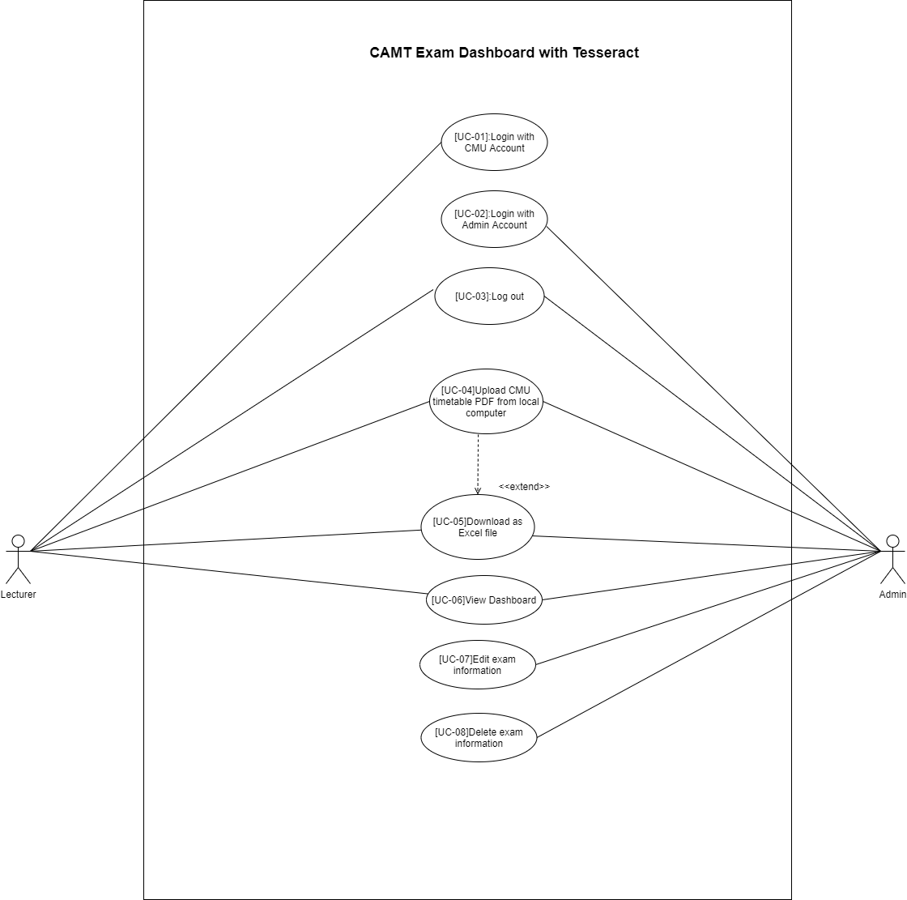2.1.1 Overview

2.1.2 Authentication System

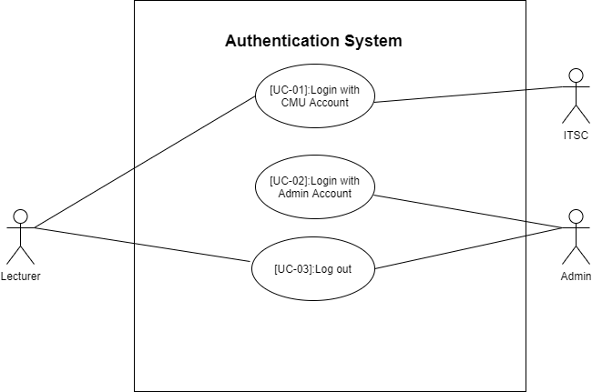

UC-01 Login with CMU Account

|  |  |  |  |  |  |
| --- | --- | --- | --- | --- | --- |
| Use Case ID | UC-01 | | | | |
| Use Case Name | Login with CMU Account | | | | |
| Created By | Lingyu Kong | | | Last Update By | Lingyu Kong |
| Date Created | 01/06/2021 | | | Last Revision Date | 30/07/2021 |
| Actors | Lecturer, ITSC | | | | |
| Description | Lecturer can use CMU account sign in to the system. | | | | |
| Trigger | The Lecturer clicks the “Login with CMU Account” button in the Login page(UI-01). | | | | |
| Preconditions | The lecturer opens the Login page(UI-01) in the system. | | | | |
| Use Case Input Specification | | | | | |
| Input | type | Constraint | | | Example |
| Email | String | Must be an ITSC format (include “@”) | | | Lingyu_k@cmu.ac.th |
| Password | String | Must be at least 6 characters and include a number | | | 123456 |
| Post conditions | - | | | | |
| Normal Flows | Lecturer | | ITSC | System | |
| 1. | The Lecturer clicks the “Sign in with CMU Account” button at the Login page(UI-01). | |  |  | |
| 2. |  | |  | The system shall direct to the Sign In With CMU IT Account page. | |
| 3. | The Lecturer fills in the email and password into the input box and clicks the “Sign In” button. | |  |  | |
| 4. |  | | ITSC system validates email and password [A1]. |  | |
| 5. |  | |  | System get authentication token from backend. | |
| 6. | Lecturer is logged in to system | |  |  | |
| 7. |  | |  | System shall display direct to the ParseFile Page(UI-02). | |
| 8. |  | |  | System shall display the lecturer’s email in the upper right corner for lecturer. | |
| Alternative Flow | [A1: Email or password invalid]  A4. System notifies the guest that “Username or Password is invalid”  A5. Goes to normal flow 3 | | | | |
| Exception Flow | - | | | | |
| Assumption | - The Lecturer understands English.  - Can connect to the internet | | | | |

URS-01: Lecturer can Login to the system by using their CMU IT Account and corresponding password which are already registered in the CMU system.

SRS-001: The system provides the login page(UI-01) which include Login panel, “Login with CMU Account” and “Login” button.

SRS-002: When lecturer click the “Login with CMU Account” button, system shall direct to the Sign In With CMU IT Account page, which includes the "Email" input box, "Password" input box, "Sign In" button, and “Forgot password?” link.

SRS-003: The system verifies the information inputted by the Lecturer when lecturer click “Sign In” button.

1. When lecturer input invalid email or password: the message “Username or Password is invalid” is shown.

SRS-004: System shall get authentication token from backend.

SRS-005: when lecturer successfully login, the system shall display direct to the ParseFile Page(UI-02).

SRS-006: The system shall display the lecturer’s email in the upper right corner for lecturer.

UC-02 Login with Admin Account

|  |  |  |  |  |
| --- | --- | --- | --- | --- |
| Use Case ID | UC-02 | | | |
| Use Case Name | Login with Admin Account | | | |
| Created By | Lingyu Kong | | Last Update By | Lingyu Kong |
| Date Created | 01/06/2021 | | Last Revision Date | 30/07/2021 |
| Actors | Admin | | | |
| Description | Admin can use admin account sign in to the system. | | | |
| Trigger | The admin clicks the “Login” button in the Login page(UI-01). | | | |
| Preconditions | The admin opens the Login page(UI-01) in the system. | | | |
| Use Case Input Specification | | | | |
| Input | type | Constraint | | Example |
| username | String | Must be at least 5 characters | | Admin |
| Password | String | Must be at least 5 characters and include a number | | 123456 |
| Post conditions | - | | | |
| Normal Flows | Admin | | System | |
| 1. | The admin fills in the email and password into the input box and clicks the “Login” button. | |  | |
| 2. |  | | The system verifies the information inputted by the Admin.[A1], [A2], [A3], [A4],[E1] | |
| 3. |  | | The system shall display the name in the upper right corner of the ParseFile page(UI-02) for admin. | |
| Alternative Flow | [A1: The lecturer did not input username.]  1. The system displays the validation message “Please enter a username”.  2. The system redirects normal flow 1.  [A2: The lecturer did not input the password.]  1. The system displays the validation message “Please enter a password”.  2. The system redirects normal flow 1.  [A3: Incorrect username.]  1. The system displays the error message “Username or Password not match”.  2. The system redirects normal flow 1.  [A4: Incorrect password]  1. The system displays the error message “Username or Password not match”.  2. The system redirects normal flow 1. | | | |
| Exception Flow | - | | | |
| Assumption | - The Lecturer understands English.  - Can connect to the internet | | | |

URS-02: Administrator Login to the system by using their Admin Account and corresponding password which are already registered in the database.

SRS-001: The system provides the login page(UI-01) which include Log In panel, “Login with CMU Account” and “Login” button.

SRS-007: The system verifies the information inputted by the admin when admin click “Login” button.

1. When admin did not input email: the message “Please enter a username” is shown.

2. When admin did not input the password: the message “Please enter a password” is shown.

3. When admin input incorrect username: the message “Username or Password not match” is shown.

4. When admin input incorrect password: the message “Username or Password not match” is shown.

SRS-008: when admin successfully sign in, the system shall direct to the ParseFile Page(UI-02).

SRS-009: The system shall display the admin’s name in the upper right corner of the ParseFile page(UI-02) for admin.

UC-03 Log out

|  |  |  |  |  |
| --- | --- | --- | --- | --- |
| Use Case ID | UC-03 | | | |
| Use Case Name | Log out | | | |
| Created By | Lingyu Kong | | Last Update By | Lingyu Kong |
| Date Created | 01/06/2021 | | Last Revision Date | 01/07/2021 |
| Actors | Admin, Lecturer | | | |
| Description | Admin or Lecturer can logout from the system | | | |
| Trigger | The administrator or lecturer clicks the "Logout" button under the email selection option on the most right of the navigation. | | | |
| Preconditions | The admin or lecturer already log in the system. | | | |
| Use Case Input Specification | | | | |
| Input | type | Constraint | | Example |
| - | - | - | | - |
| Post conditions | - | | | |
| Normal Flows | Admin | | System | |
| 1. | The admin or lecturer clicks on the email which at the most right of the navigation. | |  | |
| 2. |  | | The system should display a "Logout" button under the select option of the email of the admin or lecturer. | |
| 3. | The admin or lecturer clicks the "Log out" button which under the select option of the email of the admin or lecturer. | |  | |
| 4. |  | | The system shall log out the admin or lecturer account and redirect to the Login page(UI-01). | |
| Alternative Flow | - | | | |
| Exception Flow | - | | | |
| Assumption | - The Lecturer understands English.  - Can connect to the internet | | | |

URS-03: Admin or lecturer click “Log out” button to logout from the system.

SRS-010: when admin or lecturer clicks the “log out” button under the select option of the email of the admin or lecturer ,the system logs out the admin or lecturer account and redirects to the Login page(UI-01).

2.1.3 Table and cell detection and text extraction and parsing system

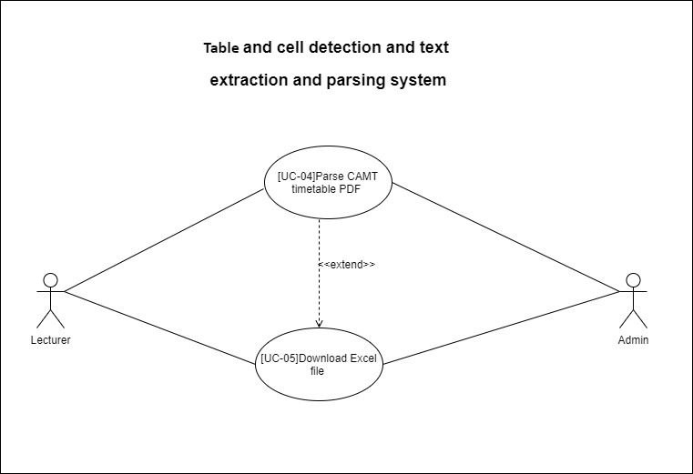

UC-04 Parse CAMT timetable PDF

|  |  |  |  |  |
| --- | --- | --- | --- | --- |
| Use Case ID | UC-04 | | | |
| Use Case Name | Parse CAMT timetable PDF | | | |
| Created By | Lingyu Kong | | Last Update By | Lingyu Kong |
| Date Created | 02/06/2021 | | Last Revision Date | 30/07/2021 |
| Actors | Lecturer, Admin | | | |
| Description | The admin or lecturer can upload CAMT timetable PDF from local computer to the system for detection and parses. | | | |
| Trigger | The admin or lecturer clicks the “Click Upload” button in the ParseFile page(UI-02). | | | |
| Preconditions | The admin or lecturer signed in to the system and open ParseFile page(UI-02). | | | |
| Use Case Input Specification | | | | |
| Input | type | Constraint | | Example |
| File | File | Must be PDF format | | Image.pdf |
| Post conditions | The system successfully detects and parses the files uploaded by the admin or lecturer and the“ Parse success”, “Download Excel” button is shown. | | | |
| Normal Flows | Lecturer | | System | |
| 1. | The admin or lecturer clicks the “ParseFile” text at the left in the navigation. | |  | |
| 2. |  | | The system shall display the ParseFile page(UI-02), which includes the title " ParseFile ", Upload panel, ”Click Upload” “Download Excel” button. | |
| 3. | The admin or lecturer clicks the Upload panel or drag file to the Upload panel. | |  | |
| 4. |  | | The system shall open the local file explorer for admin and lecturers to choose the files to upload. | |
| 5. | The admin and lecturer clicks “Click Upload” button which under the Upload panel. | |  | |
| 6. |  | | The system verify file format which uploaded by the admin or lecturer.[A1], [A2], [A3] | |
| 7. |  | | The system paring files and show “Being parse” button which under the Upload panel. [A4].[A5],[A6] | |
| 8. |  | | The system shall show “Parse success” button which under the Upload panel and store data in the database. | |
| 9. |  | | The system will no longer disable the "Download Excel" button. | |
| Alternative Flow | [A1: The file format is not PDF format]  1. The system displays the message “file type does not meet the requirement, only is application/pdf”.  2. The system shall displays the “Parse failed” button which under the Upload panel.  3. The system redirects normal flow 3.  [A2: The file is an empty PDF file]  1. The system displays the message “file is empty”.  2. The system shall displays the “Parse failed” button which under the Upload panel.  3. The system redirects normal flow 3.  [A3: The size of file is exceed max size ]  1. The system displays the message “file size cant exceed 10 MB”.  2. The system shall displays the “Parse failed” button which under the Upload panel.  3. The system redirects normal flow 3.  [A4: The number of pages of the pdf document is less than 0]  1. The system displays the message “pdf transcode img failed”.  2. The system shall displays the “Parse failed” button which under the Upload panel.  3. The system redirects normal flow 3.  [A5:Not files exist in the pdfImgDirPath]  1. The system displays the message “no such files to extract table”.  2. The system shall displays the “Parse failed” button which under the Upload panel.  3. The system redirects normal flow 3.  [A6: Not files exist in the tableImgDirPath ]  1. The system displays the message “no such files to extract table”.  2. The system shall displays the “Parse failed” button which under the Upload panel.  3. The system redirects normal flow 3. | | | |
| Exception Flow | - | | | |
| Assumption | - The Lecturer understands English.  - Can connect to the internet | | | |

URS-04: The admin or lecturer can upload the CAMT timetable PDF from the local computer to the system for detection and parses.

SRS-011: When admin or lecturer clicks the “ParseFile” text at the left in the navigation, the system shall display the ParseFile page(UI-02), which includes the title " ParseFile ", Upload panel, ”Click Upload” “Download Excel” button.

SRS-012: When admin or lecturer clicks the Upload panel or drag file to the Upload panel, the system shall open the local file explorer for admin or lecturers to upload file.

SRS-013: When admin and lecturer clicks “Click Upload” button which under the Upload panel, the system shall verify file format which uploaded by the admin or lecturer.

1. When admin or lecturer upload prohibited file formats: the message “file type does not meet the requirement, only is application/pdf” and “Parse failed” button is shown.

2. When admin or lecturer upload empty pdf file : the message “file is empty” and “Parse failed” button is shown.

3. When admin or lecturer upload other pdf file: the message “file size cant exceed 10 MB” and “Parse failed” button is shown.

SRS-014: When verify file format is complete, the system shall start paring files and show “Being parse” button which under the Upload panel.

1. When the number of pages of the pdf file is less than 0: the message “pdf transcode img faile” and “Parse failed” button is shown.

2. When no file exists in the pdfImgDirPath directory: the message “no such files to extract table” and “Parse failed” button is shown.

3. When no files exist in the tableImgDirPath directory: the message “no such files to extract table” and “Parse failed” button is shown.

SRS-015: When parse file is complete, the system shall show “Parse success” button which under the Upload panel and store data in the database.

SRS-016: When parse file is complete, the system will no longer disable the "Download Excel" button.

UC-05 Download Excel file

|  |  |  |  |  |
| --- | --- | --- | --- | --- |
| Use Case ID | UC-05 | | | |
| Use Case Name | Download Excel file | | | |
| Created By | Lingyu Kong | | Last Update By | Lingyu Kong |
| Date Created | 02/06/2021 | | Last Revision Date | 30/07/2021 |
| Actors | Lecturer, Admin | | | |
| Description | The admin or lecturer can Download Parsed Excel file from the system | | | |
| Trigger | The admin or lecturer clicks the “Download Excel” button in the ParseFile page(UI-02). | | | |
| Preconditions | “Parse success” button is shown and "Download Excel" button is not disable. | | | |
| Use Case Input Specification | | | | |
| Input | type | Constraint | | Example |
| - | - | - | | - |
| Post conditions | - | | | |
| Normal Flows | Lecturer | | System | |
| 1. | The admin or lecturer clicks the "Download EXCEL" button which under the Upload panel. | |  | |
| 2. |  | | The system shall download file to admin or lecturer local computer.[A1],[A2] | |
| Alternative Flow | [A1: The corresponding file was not found]  1. The system displays the message “not such fileRecord, id: ($id)”.  2. The system redirects normal flow 1.  [A1: The corresponding file does not exist ]  1. The system displays the message “not such file, file name ($name)”.  2. The system redirects normal flow 1. | | | |
| Exception Flow | - | | | |
| Assumption | - The Lecturer understands English.  - Can connect to the internet | | | |

URS-05: The admin or lecturer can Download Parsed Excel file from the system

SRS-017: When admin or lecturer click “Download Excel” button, the system shall download file to admins or lecturers local computer.

1. When the corresponding file is not found in the database: the message “not such fileRecord, id: ($id)” is shown.

2. When there is no corresponding file in the filestoragePath: the message “no such file, file name ($name)” is shown.

2.1.4 Dashboard System

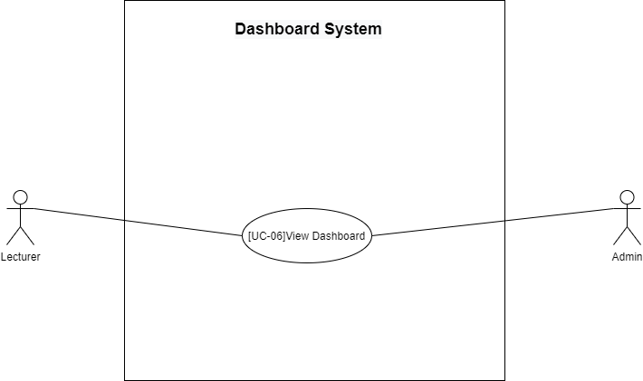

UC-06 View Dashboard

|  |  |  |  |  |
| --- | --- | --- | --- | --- |
| Use Case ID | UC-06 | | | |
| Use Case Name | View Dashboard | | | |
| Created By | Lingyu Kong | | Created By | Lingyu Kong |
| Date Created | 06/09/2021 | | Last Revision Date | 07/10/2021 |
| Actors | Lecturer, Admin | | | |
| Description | Lecturer and Admin can view dashboard. | | | |
| Trigger | The Lecturer/Admin clicks the “Dashboard” button at the left navigation bar. | | | |
| Preconditions | The lecturer/Admin logged in to the system. | | | |
| Use Case Input Specification | | | | |
| Input | type | Constraint | | Example |
| - | - | - | | - |
| Post conditions | The dashboard is rendered by the page. | | | |
| Normal Flows | Admin | | System | |
| 1. | The admin/lecturer click “Dashboard” at left navigation Bar. | |  | |
| 2. |  | | The system shall direct to the Dashboard page(UI-04) which includes count of courses, sections, protectors and pie chart of groupbydate, groupbycourse, groupbyprofesstional. | |
| Alternative Flow | - | | | |
| Exception Flow | - | | | |
| Assumption | - The Lecturer understands English.  - Can connect to the internet | | | |

URS-06: The admin or Lecturer can view dashboard of exam information.

SRS-018: The system shall direct to the Dashboard page(UI-04) which includes count of courses, sections, protectors and pie chart of groupbydate, groupbycourse, groupbyprofessional.

2.1.5 Notification system

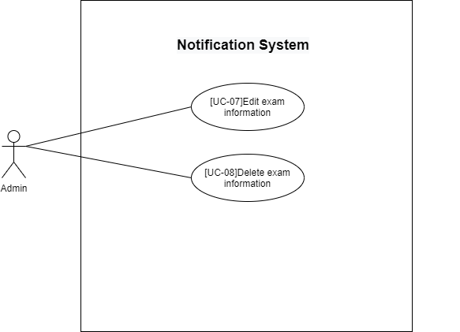

UC-07 Edit exam information

|  |  |  |  |  |
| --- | --- | --- | --- | --- |
| Use Case ID | UC-07 | | | |
| Use Case Name | Edit exam information | | | |
| Created By | Lingyu Kong | | Created By | Lingyu Kong |
| Date Created | 06/09/2021 | | Last Revision Date | 26/09/2021 |
| Actors | Admin | | | |
| Description | Admin can edit exam information. | | | |
| Trigger | The Admin clicks the “Edit” button at exam list at the ExaminfoList page(UI-05). | | | |
| Preconditions | The Admin logged in to the system and arrived to the ExaminfoList page(UI-05). | | | |
| Use Case Input Specification | | | | |
| Input | type | Constraint | | Example |
| Date | String | Less than 64 characters | | “Thursday 28January, 2021” |
| Time | String | Less than 64 characters | | “15.30-18.30” |
| Course | String | Less than 64 characters | | “954491” |
| Section | String | Less than 32 characters | | “002” |
| Students | String | Less than 32 characters | | “30” |
| Room | String | Less than 32 characters | | “ILLC-B201” |
| Committee | String | Less than 100 characters | | “Lingyu Kong” |
| Post conditions | The data has been synchronized and the message "Update Successfully" is displayed at the upper right corner and email notification has been send. | | | |
| Normal Flows | Admin | | System | |
| 1. | The admin click “ExamInfoList” button at left navigation Bar. | |  | |
| 2. |  | | The system shall display the ExamInfoList page(UI-05) which includes exam information table, “Edit” and “Cancel” button. | |
| 3. | The admin click “Edit” button at row “Actions” at most right of exam information table. | |  | |
| 4. |  | | The system shall display edit form(UI-06) which include 7 input box(Date, Time, Course, Section, Students, Room, Committee, Actions) “Cancel” and “Confirm” button. | |
| 5. | The admin edits the exam information in the input box. | |  | |
| 6. | The admin click “Confirm” button to save information.[A1] | |  | |
| 7. |  | | The system display notification dialog(UI-07) which includes text “Do you want to send email notification?”, “Cancel” and “Send” button. | |
| 8. | The admin click “Confirm” button to send Email notification.[A2] | |  | |
| 9. |  | | The system synchronize data display message “Update Successfully” at upper right corner and Send email notification to the committee.[A3] [A4] | |
| Alternative Flow | [A1: The Admin click “Cancel” button at edit form]  1. The system redirects normal flow 2.  [A2: The Admin click “Cancel” button at send email dialog]  1. The system synchronize data and display message “Update Successfully” at upper right corner.  [A3: failed to update date in database]  1. The system display “Update examInfo data failed, please contact admin”  2. The system redirects normal flow 2.  [A4: Email is invalid]  1. The system display “recipient email is invalid($email)”.  2. The system redirects normal flow 2. | | | |
| Exception Flow | - | | | |
| Assumption | - The Lecturer understands English.  - Can connect to the internet | | | |

URS-07: The admin or lecturer can edit exam information.

SRS-019: When admin clicks the “ExamInfoList” text at left navigation Bar, the system shall display the ExamInfoList page(UI-05) which includes exam information table, “Edit” and “Delete” button.

SRS-020: When admin clicks the “Edit” text at row “Actions” at most right of exam information table, the system shall display edit form(UI-06) which include 7 input box(Date, Time, Course, Section, Students, Room, Committee, Actions) “Cancel” and “Confirm” button.

1. When admin click “Cancel” button: the system will close edit form.

SRS-021: When admin clicks the “Confirm” button at edit form(UI-06), the system display notification dialog(UI-07) which includes text “Do you want to send email notification?”, “Cancel” and “Send” button.

1. When admin clicks “Confirm” button : the system will send email notification to the committee and the message “Update Successfully” is shown.

2. When admin clicks “Cancel” button : the system will not send email notification to the committee and the message “Update Successfully” is shown.

3. When failed to update data in database : the message “Update examInfo data failed, please contact admin” is shown.

4. When recipient email is invalid: the message “recipient email is invalid($email)” is shown.

UC-08 Delete exam information

|  |  |  |  |  |
| --- | --- | --- | --- | --- |
| Use Case ID | UC-08 | | | |
| Use Case Name | Delete exam information | | | |
| Created By | Lingyu Kong | | Last Update By | Lingyu Kong |
| Date Created | 06/09/2021 | | Last Revision Date | 26/09/2021 |
| Actors | Admin | | | |
| Description | The admin can delete exam information | | | |
| Trigger | The Admin clicks the “Delete” button at exam list at the ExaminfoList page(UI-05) | | | |
| Preconditions | The Admin logged in to the system and arrived to the ExaminfoList page(UI-05). | | | |
| Use Case Input Specification | | | | |
| Input | type | Constraint | | Example |
| - | - | - | | - |
| Post conditions | The data has been synchronized and the message "Delete Successfully" is displayed at the upper right corner. | | | |
| Normal Flows | Lecturer | | System | |
| 1. | The admin click “ExamInfoList” button at left navigation Bar. | |  | |
| 2. |  | | The system shall display the ExamInfoList page(UI-05) which includes exam information table, “Edit” and “Delete” button. | |
| 3. | The admin click “Delete” button at row “Actions” at most right of exam information table. | |  | |
| 4. |  | | The system display notification dialog(UI-07) which includes text “Do you want to send email notification?”, “Cancel” and “Send” button. | |
| 5. | The admin click “Confirm” button to send Email notification.[A1] | |  | |
| 6. |  | | The system synchronize data display message “Update Successfully” at upper right corner and Send email notification to the committee.[A2][A3] | |
| Alternative Flow | [A1: The Admin click “Cancel” button at send email dialog]  1. The system synchronize data and display message “delete Successfully” at upper right corner.  [A2: failed to delete date in database]  1. The system display “Delete examInfo data failed, please contact admin”  2. The system redirects normal flow 2.  [A3: Email is invalid]  1. The system display “recipient email is invalid($email)”.  2. The system redirects normal flow 2. | | | |
| Exception Flow | - | | | |
| Assumption | - The Lecturer understands English.  - Can connect to the internet | | | |

URS-08: The admin can delete exam information.

SRS-019: When admin clicks the “ExamInfoList” text at left navigation Bar, the system shall display the ExamInfoList page(UI-05) which includes exam information table, “Edit” and “Delete” button.

SRS-22: When admin clicks the “Delete” text at row “Actions” at most right of exam information table, the system shall display notification dialog(UI-07) which includes text “Do you want to send email notification?”, “Cancel” and “Send” button.

1.When admin clicks “Confirm” button : the system will send email notification to the committee and the message “Delete Successfully” is shown.

2. When admin clicks “Cancel” button : the system will not send email notification to the committee and the message “Delete Successfully” is shown.

3. When failed to delete data in database : the message “Delete examInfo data failed, please contact admin” is shown.

4. When recipient email is invalid: the message “recipient email is invalid($email)” is shown.

2.2 User requirement Specification

2.2.1 Progress I

**Feature 1: Authentication System**

**URS-01**: Lecturer can Login to the system by using their CMU IT Account and corresponding password which are already registered in the CMU system.

**URS-02**: Administrator Login to the system by using their Admin Account and corresponding password which are already registered in the database.

**URS-03**: Admin or lecturer click “Log out” button to logout from the system.

**Feature 2: Table and cell detection and text extraction and parsing system**

**URS-04**: The admin or lecturer can upload the CAMT timetable PDF from the local computer to the system for detection and parses.

**URS-05**: The admin or lecturer can Download Parsed Excel file from the system

2.2.1 Progress II

**Feature 3: Dashboard System**

**URS-06**: The admin or Lecturer can view dashboard of exam information.

**Feature 4: Notification System**

**URS-07**: The admin or lecturer can edit exam information.

**URS-08**: The admin can delete exam information.

2.2 System requirement Specification

2.2.1 Progress I

**SRS-001**: The system provides the login page(UI-01) which include Login panel, “Login with CMU Account” and “Login” button.

**SRS-002**: When lecturer click the “Login with CMU Account” button, system shall direct to the Sign In With CMU IT Account page, which includes the "Email" input box, "Password" input box, "Sign In" button, and “Forgot password?” link.

**SRS-003**: The system verifies the information inputted by the Lecturer when lecturer click “Sign In” button.

1. When lecturer input invalid email or password: the message “Username or Password is invalid” is shown.

**SRS-004**: System shall get authentication token from backend.

**SRS-005**: when lecturer successfully login, the system shall display direct to the ParseFile Page(UI-02).

**SRS-006**: The system shall display the lecturer’s email in the upper right corner for lecturer.

**SRS-007**: The system verifies the information inputted by the admin when admin click “Login” button.

1. When admin did not input email: the message “Please enter a username” is shown.

2. When admin did not input the password: the message “Please enter a password” is shown.

3. When admin input incorrect username: the message “Username or Password not match” is shown.

4. When admin input incorrect password: the message “Username or Password not match” is shown.

**SRS-008**: when admin successfully sign in, the system shall direct to the ParseFile Page(UI-02).

**SRS-009**: The system shall display the admin’s name in the upper right corner of the ParseFile page(UI-02) for admin.

**SRS-010**: when admin or lecturer clicks the “log out” button under the select option of the email of the admin or lecturer ,the system logs out the admin or lecturer account and redirects to the Login page(UI-01).

**SRS-011**: When admin or lecturer clicks the “ParseFile” text at the left in the navigation, the system shall display the ParseFile page(UI-02), which includes the title " ParseFile ", Upload panel, ”Click Upload” “Download Excel” button.

**SRS-012**: When admin or lecturer clicks the Upload panel or drag file to the Upload panel, the system shall open the local file explorer for admin or lecturers to upload file.

**SRS-013**: When admin and lecturer clicks “Click Upload” button which under the Upload panel, the system shall verify file format which uploaded by the admin or lecturer.

1. When admin or lecturer upload prohibited file formats: the message “file type does not meet the requirement, only is application/pdf” and “Parse failed” button is shown.

2. When admin or lecturer upload empty pdf file : the message “file is empty” and “Parse failed” button is shown.

3. When admin or lecturer upload other pdf file: the message “file size cant exceed 10 MB” and “Parse failed” button is shown.

**SRS-014**: When verify file format is complete, the system shall start paring files and show “Being parse” button which under the Upload panel.

1. When the number of pages of the pdf file is less than 0: the message “pdf transcode img faile” and “Parse failed” button is shown.

2. When no file exists in the pdfImgDirPath directory: the message “no such files to extract table” and “Parse failed” button is shown.

3. When no files exist in the tableImgDirPath directory: the message “no such files to extract table” and “Parse failed” button is shown.

**SRS-015**: When parse file is complete, the system shall show “Parse success” button which under the Upload panel and store data in the database.

**SRS-016**: When parse file is complete, the system will no longer disable the "Download Excel" button.

**SRS-017**: When admin or lecturer click “Download Excel” button, the system shall download file to admins or lecturers local computer.

1. When the corresponding file is not found in the database: the message “not such fileRecord, id: ($id)” is shown.

2. When there is no corresponding file in the filestoragePath: the message “no such file, file name ($name)” is shown.

2.2.1 Progress II

**SRS-018**: The system shall direct to the Dashboard page(UI-04) which includes count of courses, sections, protectors and pie chart of groupbydate, groupbycourse, groupbyprofessional.

**SRS-019**: When admin clicks the “ExamInfoList” text at left navigation Bar, the system shall display the ExamInfoList page(UI-05) which includes exam information table, “Edit” and “Delete” button.

**SRS-020**: When admin clicks the “Edit” text at row “Actions” at most right of exam information table, the system shall display edit form(UI-06) which include 7 input box(Date, Time, Course, Section, Students, Room, Committee, Actions) “Cancel” and “Confirm” button.

1. When admin click “Cancel” button: the system will close edit form.

**SRS-021**: When admin clicks the “Confirm” button at edit form, the system display notification dialog(UI-07) which includes text “Do you want to send email notification?”, “Cancel” and “Send” button.

1. When admin clicks “Confirm” button : the system will send email notification to the committee and the message “Update Successfully” is shown.

2. When admin clicks “Cancel” button : the system will not send email notification to the committee and the message “Update Successfully” is shown.

3. When failed to update data in database : the message “Update examInfo data failed, please contact admin” is shown.

4. When recipient email is invalid: the message “recipient email is invalid($email)” is shown.

**SRS-22**: When admin clicks the “Delete” text at row “Actions” at most right of exam information table, the system shall display notification dialog(UI-07) which includes text “Do you want to send email notification?”, “Cancel” and “Send” button.

1.When admin clicks “Confirm” button : the system will send email notification to the committee and the message “Delete Successfully” is shown.

2. When admin clicks “Cancel” button : the system will not send email notification to the committee and the message “Delete Successfully” is shown.

3. When failed to delete data in database : the message “Delete examInfo data failed, please contact admin” is shown.

4. When recipient email is invalid: the message “recipient email is invalid($email)” is shown.

Chapter Two | Activity Diagram

3.1 Authentication System

AD-01: Login with CMU Account

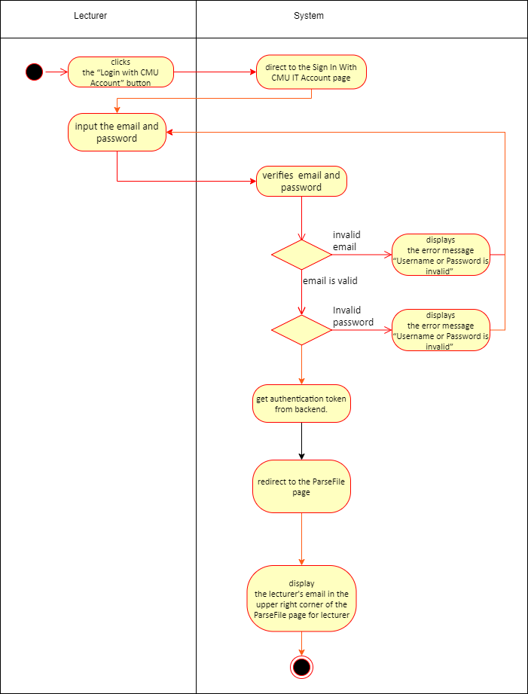

AD-02: Login with Admin Account

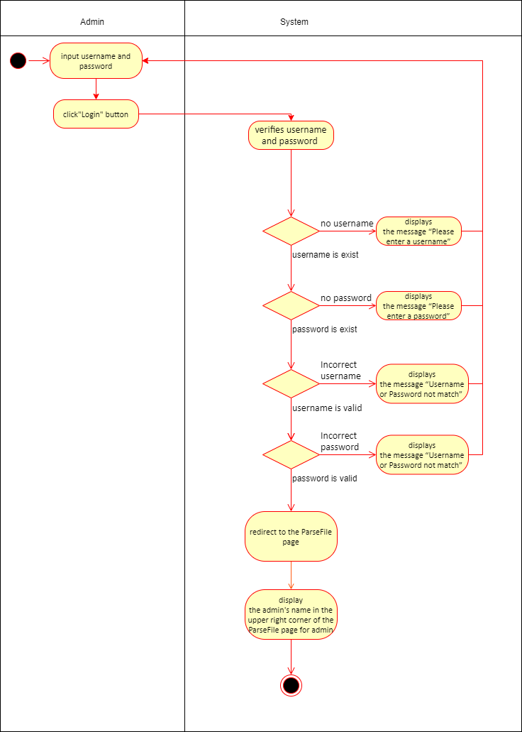

AD-03: Log out

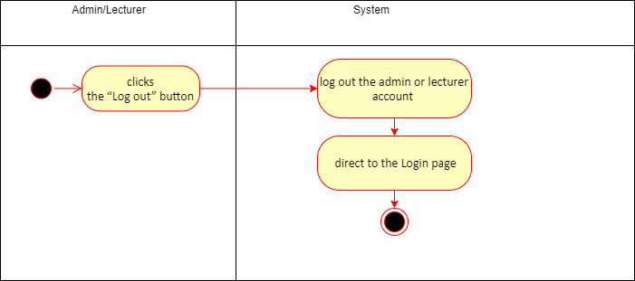

3.2 Activity diagram for Feature #2: Table and cell detection and text extraction and parsing system

AD-04: Parse CAMT timetable PDF

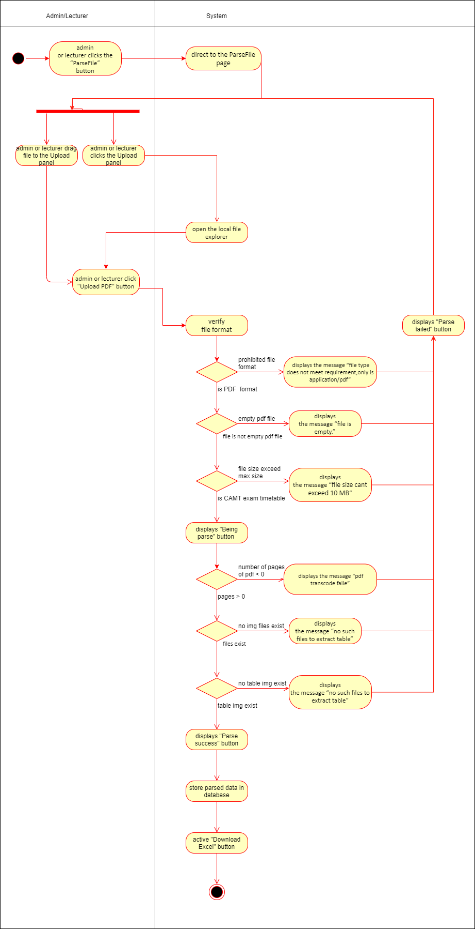

AD-05: Download Excel file

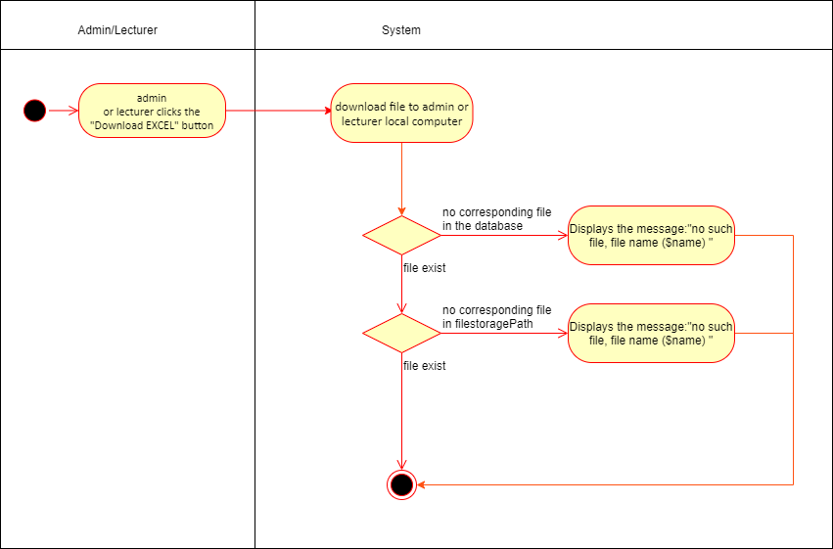

3.3 Activity diagram for Feature #3: Dashboard System

AD-06: View Dashboard

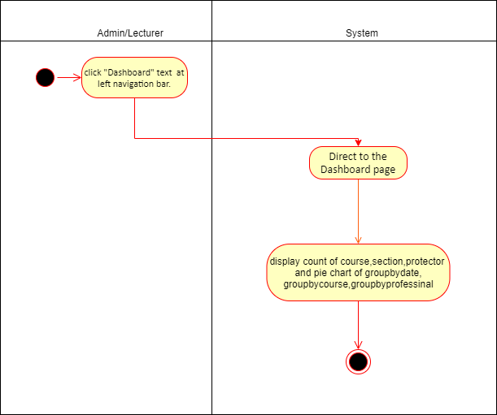

3.4 Activity diagram for Feature #4:Notification system

AD-07: Edit exam information

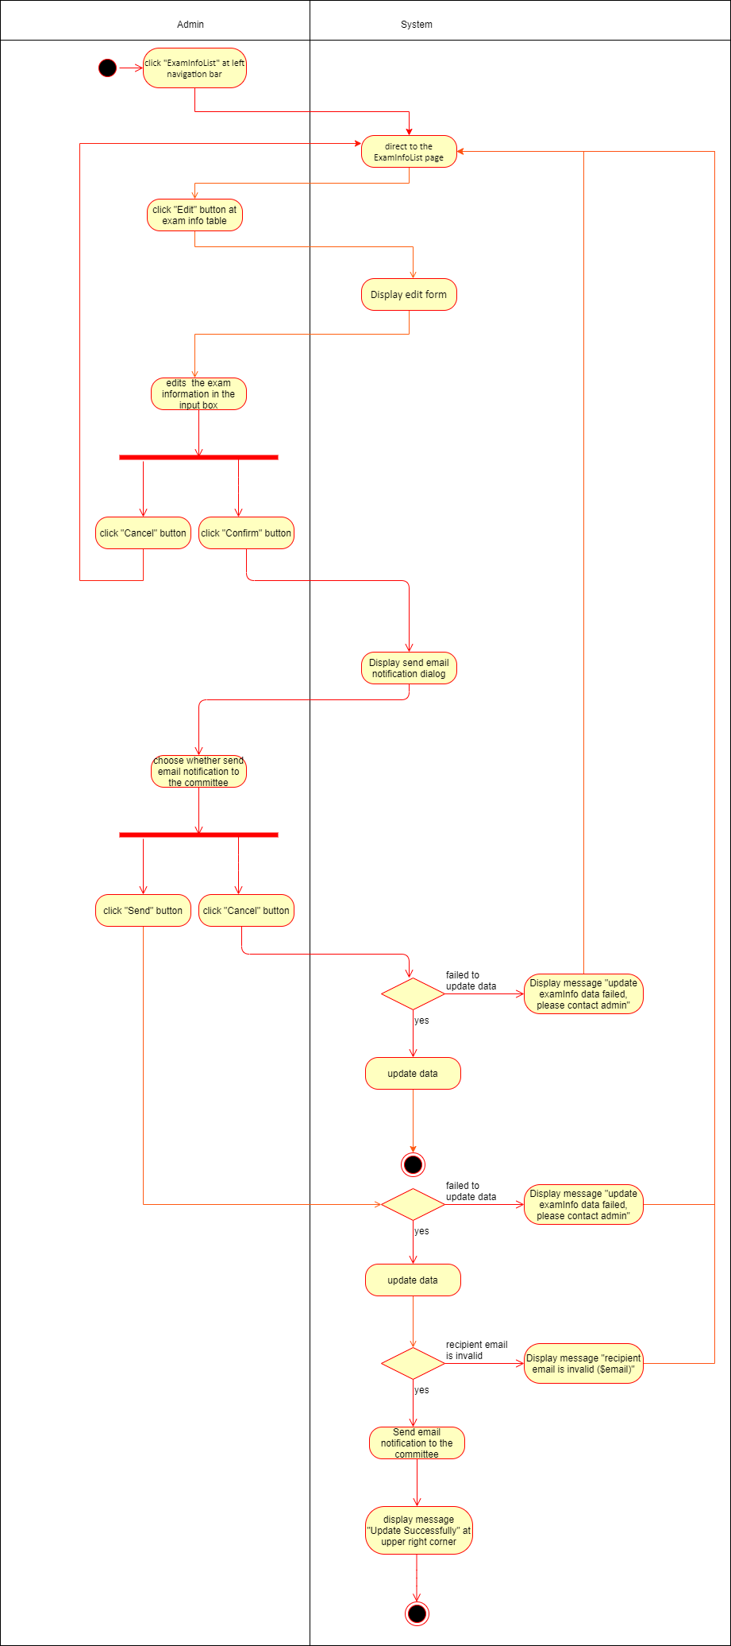

AD-08: Delete exam information

